Golf Strengthening Program

The strengthening exercises in this program are just a few of the many exercises in the golf training world. I try and focus on exercises that directly influence the golf swing motion. Like many exercises, too much of one type can influence a muscle group beyond a flexible, smooth flowing muscle into a tense, hardened muscle. In the golf swing, a strong and supportive core joined with a strong and flexible upper torso and shoulders, will give the best results regardless of body type.

If you are currently injured, you need to see a sports medicine doctor to get the right Rx.

If you are looking to improve your strength and flexibility, perform the stretches and exercises shown in this handout.

Perform all strengthening exercises slowly and carefully. Remember to breathe and STAY RELAXED!
Neck and Upper Body

1. Forearm Strengthening: Hold golf club with normal grip (one-handed). While keeping arm relatively straight, hinge and unhinge wrist. Start at mid shaft and work towards the grip as you get stronger.


1. Neck Stretch. Place right hand on top of head – Slowly pull head towards the right shoulder. Switch hands.

2. Forearm Strengthening: holding club in the middle of shaft, Slowly turn palm down and back. Hold arm in front of you or rest on a table.



3. Balance Drill: Taking normal stance, swing club back to 9:00 position. On the backswing, as club is approaching 8:00, lift the forward leg off the ground. At 9:00 put foot back on the ground and allow arms to naturally swing to follow through 9:00 position. And allow back leg to lift off the ground.

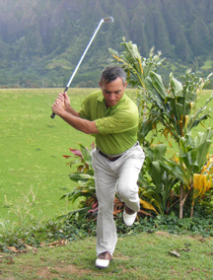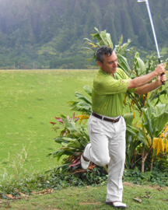

4. Shoulder Internal/External Rotations: Use Elastic Band or rubber, Attach to a door knob and hold the other end with elbow bent 90 degrees. Keeping elbow secured at side, pull hand across abdomen and slowly back to start. Switch hands.


4. External Rotation: Hold head of golf club in right hand with the club hanging off the back of the arm and parallel to the forearm. With the left hand reach up and grasp the grip and slowly raise forward.

5. Shoulder Diagonal Rotation: Stand on end of elastic band or rubber with left foot. Hold other end in right hand and pull up and across the right shoulder.

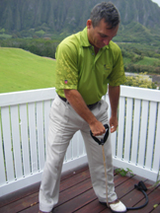

6. Shoulder Pull Down With band attached to top or door or similar, take the normal golf address position. With left hand holding band at 8-9:00 position, pull down through contact position. Allow for proper arm rotation when stronger.
6. Shoulder Pull Down With band attached to top or door or similar, take the normal golf address position. With left hand holding band at 8-9:00 position, pull down through contact position. Allow for proper arm rotation when stronger.

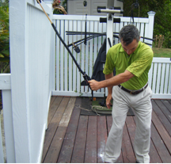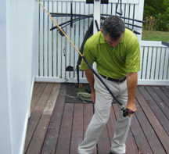
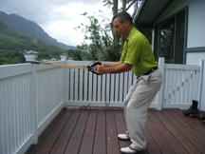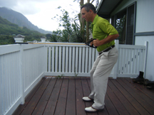
7. Rowing: Stand with good address position. Pull band ends with each hand towards chest and allow shoulder blades to “pinch” together.

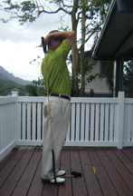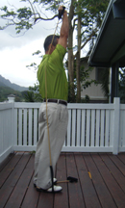
8. Tricep: Pull: Standing on one end of the band, hold other end in right hand and raise hand close to right ear. Keeping shoulder, elbow, and hand in a straight line, lift hand upwards to straighten arm and slowly lower back to position.

9. Address Position Drill: Place club behind back with grip touching head and clubhead against buttocks. Slowly bend forward at hips keeping straight spine angle, to the point where balance is almost lost or no longer comfortable. This is not a repetition drill but more for feel and balance.
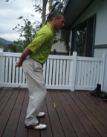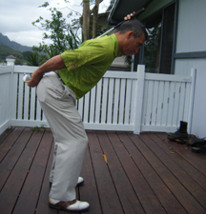
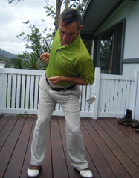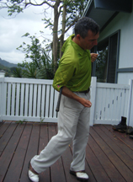
10. Standing Rotation: Assume good golf address position and hold club between elbows and lower back. Slowly turn to the back swing side and reverse to the follow through. I like to allow my legs to work just as if I’m swing a club.

11. Trunk Rotations: with band attached to top of door or other similar height, grasp both ends of band just under the armpit of the right arm. With right hand resting on left shoulder, rotate torso into impact and follow through position. Allow your footwork to help the rotation.

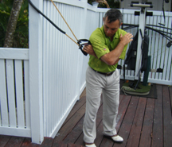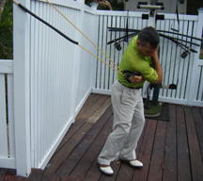

12. Seated Trunk Rotation: With band attached to door knob or similar height, Grasp other end of band. Keeping arms at same distance away from body, turn the torso to the left and hold. Slowly allow elastic of band to pull you back to the right . . .Slowly.


